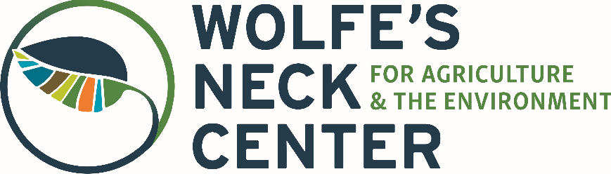
Spring Seasonal Educator SUB

184 Burnett Road, Freeport, ME 04032
Phone: (207) 865-4469 | Fax: (207) 865-4884
Website: www.wolfesneck.org

About Our Organization
Wolfe’s Neck Center for Agriculture & the Environment is on a mission to transform our relationship with farming and food for a healthier planet. We are a nonprofit education and research center situated on 626 acres of farmland, forest, and coast in Freeport, Maine. Our campus consists of an organic dairy program, livestock barns, diversified fruit and vegetable production, an oceanfront campground, and miles of wooded hiking trails. As a working farm located within a unique mix of ecosystems, we offer a remarkable and inspiring place for visitors of all ages to learn and play. Our year-round programs include farmer training, field trips, workshops, weekend events, and more.

Our Farm Discovery School Program
Farm Discovery School is Wolfe’s Neck’s way of supporting the families of the local school districts as they reimagine education in the midst of the COVID-19 pandemic. Participants will engage in hands-on learning about sustainable agriculture and the environment while taking care of livestock, tending our gardens, and exploring nearby ecosystems. The majority of this programming will occur outside, and proper health and safety measures will take place (health pre-screenings, face masks, etc.) to ensure the safety of participants and staff. Our program dates are March 15 – June 4.

Role & Responsibilities
Spring Educator Subs will be on-call and able to jump into program on an as needed basis, with responsibilities for the following:
- Take responsibility for a group of kids, ages varying between 5-11
- Lead farm-based education activities, providing appropriate structure and supervision for their age group
- Cultivate a supportive, respectful and safe learning environment for youth, ensuring an exciting experience
- Ensure proper COVID-19 safety measures (safe distancing, wearing masks while indoors) are followed

Qualifications
- Experience working with children or youth, especially in an experiential or outdoor setting
- Experience with and/or knowledge of sustainable agriculture, farming, gardening, or livestock
  - Bachelor’s degree in biology, environmental science, ag science, education, or a related field preferred
- Experience leading any of the following activities: arts & crafts, music, theater, nature exploration, or science
- Ability to manage risk and exercise judgment on a working farm, and adapt on the fly with a keen eye for safety
- Ability to work outside in a variety of environments and weather (including cold, rain, and possible snow)
- Valid driver’s license. Must be 21 or older to apply

Due to the ongoing COVID-19 pandemic and current CDC restrictions, Maine residents or residents of Maine-exempt states strongly encouraged to apply. Applications from non-exempt states will not be considered.

Terms of Employment
This is an AS NEEDED SUB, seasonal position, with a duration of March 15 – June 4 for FDS program. Typical working hours are Monday through Friday, between 7:30am-4pm. Documentation establishing your right to work in the United States is required along with the completion of a successful background check. Compensation includes: $14/hr; 25% discount on farm products (including meat, eggs, and seasonal produce). Applicants must provide their own housing.

To Apply
Please submit an Online Application along with your cover letter and resume. For more details about Farm Discovery School, please visit our website. If you have any questions about the application process, please contact Molly Cyr, Farm Camps Manager: mcyr@wolfesneck.org. Applications will be reviewed on a rolling basis until we fill the position.

Wolfe’s Neck Center for Agriculture & the Environment does not discriminate on the basis of any protected category. Applicants are selected based on their ability to perform the essential functions of the job, prior related work experience, and references from previous employers.

